**Project Documentation**

Summary:

This program generates a pyramid, diamond and other shaped pattern using numbers, characters and alphabets. It takes input from user (number of rows/column), then constructs the patterns.

Facts of Project:

1. **Input:**
   * The user is prompted to input the number of rows for the diamond, pyramid, square.
2. **Pattern Structure:**
   * The user is prompted to input the number of rows for the diamond, pyramid, square

**3.Logic for Spacing:**

* + Spaces are added before numbers to center-align the in each row or column.

**Code Explanation:**

**1.Input Handling:**

* + The variable r represents the number of rows.
  + cin >> r; captures the user's input.

**2.Upper Loop:**

* + **Outer Loop (Rows):**
  + Iterates r times.
  + **Inner Loops:**
    - The first inner loop (j) creates spaces.
    - The second inner loop (k) places numbers at the edges and spaces in between.

**3.Loop:**

**For Loops:**

For loop is used for executing a block of statements repeatedly until a particular condition is satisfied. A loop consists of an initialization statement, a test condition and an increment statement.

Syntax:

For (initialization; condition; update){}

**4.Number Placement:**

* + Conditional logic ensures numbers are printed only at the edges (k == 0 || k == I).

**Sample Output**

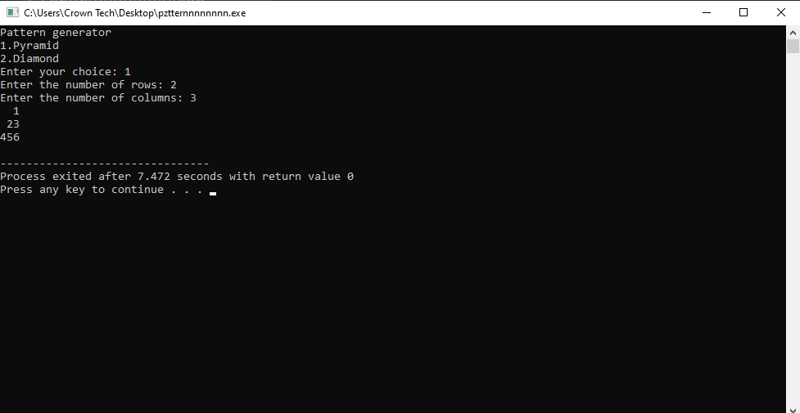

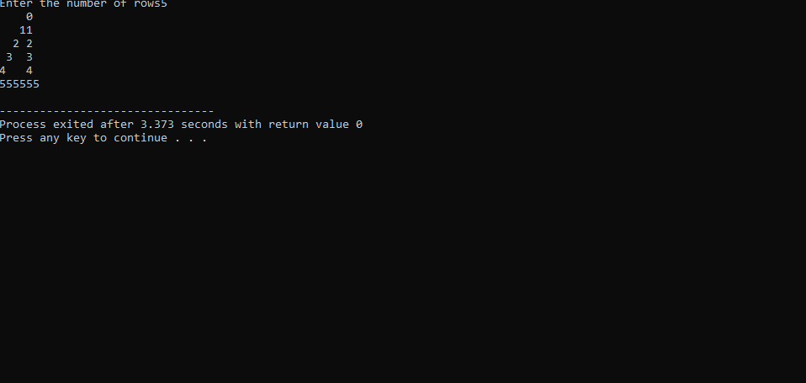

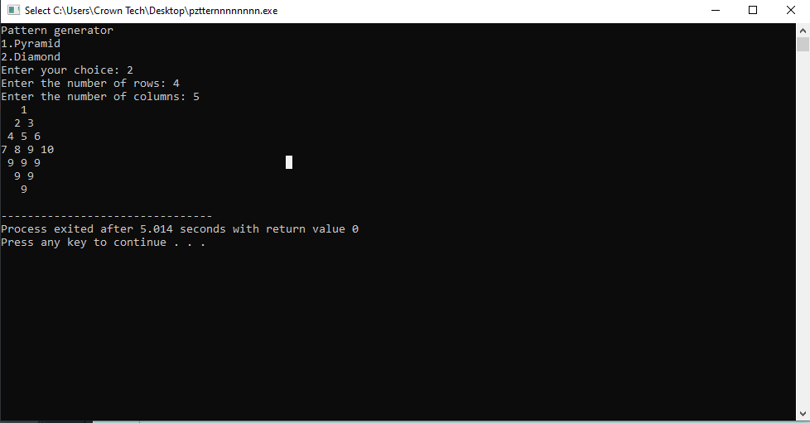



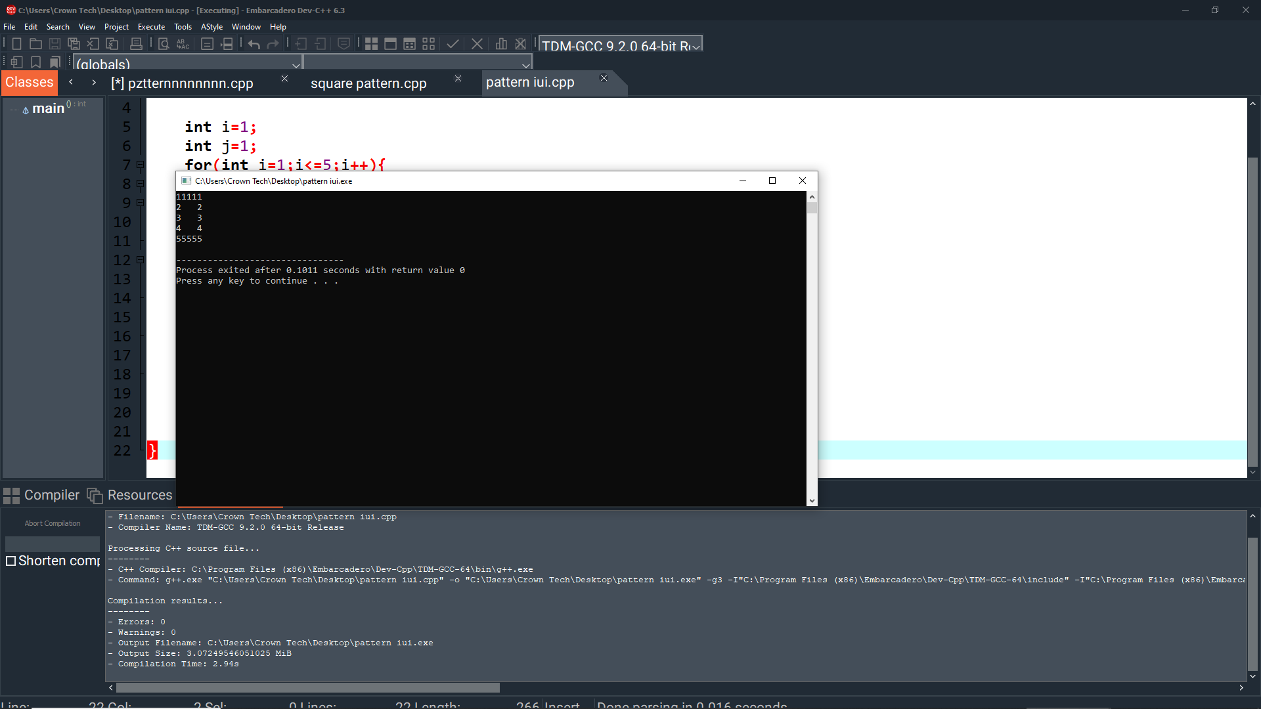

**Use Cases**

* Demonstrates basic loops (for loops) and conditional logic.
* Introduces formatting concepts (alignment using spaces).
* Useful for beginner-level understanding of nested loops and pattern generation.

Represented By:

BSCS - 1

**Hafsa Ishfaq 501121**

**Aliza Tariq 500921**